

ASSIGNMENT TITLE

SQL FUNCTIONS ASSIGNMENT ANSWER EXPLANATION

Submitted by:
Name: Sachin Brijesh Yadav
Course: Data Analytics With AI
Batch: September 2025 Live (Pro Batch)
Registered Email ID: sachinyadav9496@gmail.com

Create Table
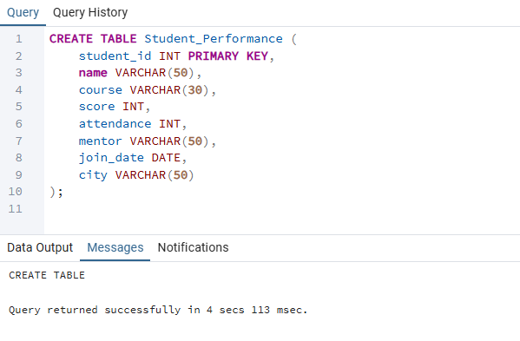
Insert Data
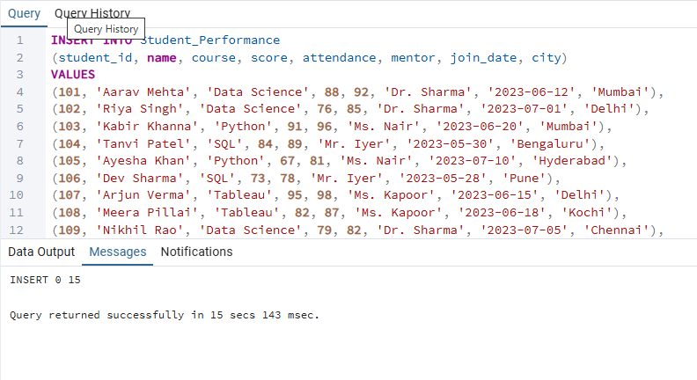

QUESTION 1 – Create a ranking of students based on score (highest first).

Concept:
Use RANK() or DENSE_RANK() window function ordered by score descending.

SQL Query:
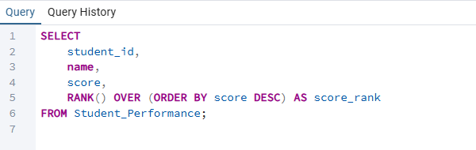
Output:
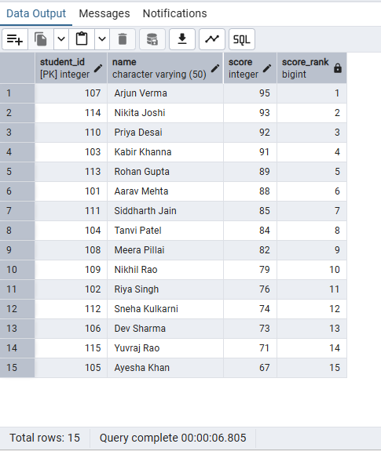

Explanation:
- Students with the same score get the same rank.
- Ranking starts from highest score → lowest.

QUESTION 2 – Show each student’s score and previous student’s score (based on score order).

Concept:
Use LAG() window function.

SQL Query:
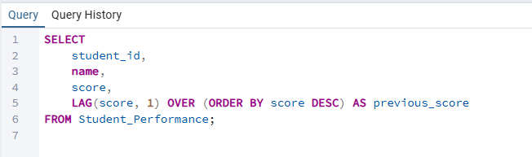
Output:
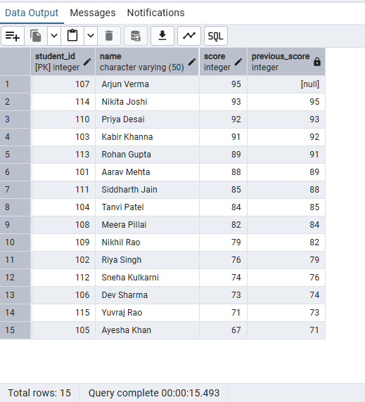

Explanation:
- LAG() extracts the score of the student immediately above in ranking.
- The top student has NULL as previous score.

QUESTION 3 – Convert all student names to uppercase AND extract month name from join_date.

SQL Query:
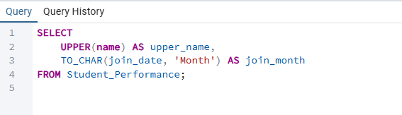
Output:
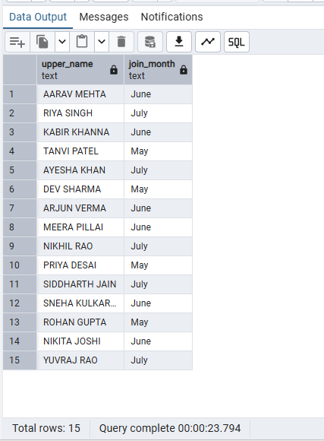

Explanation:
- UPPER() → converts name to uppercase.
- MONTHNAME() → converts date to month (e.g., June).

QUESTION 4 – Show each student’s name and the next student’s attendance.

Concept:
Use LEAD() function ordered by attendance ascending.

SQL Query:

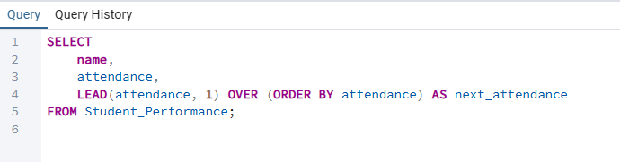

Output:

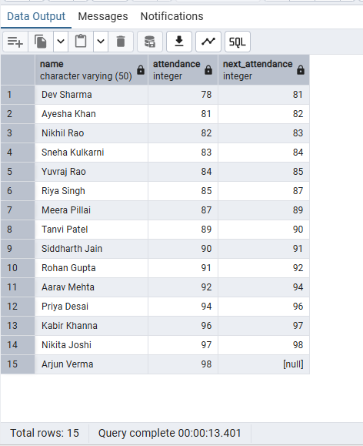

Explanation:
Shows how a student's attendance compares to the next student.

QUESTION 5 – Assign students into 4 performance groups using NTILE().

SQL Query:
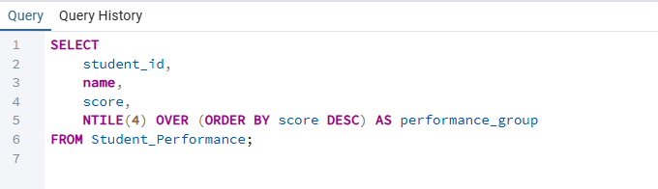
Output:
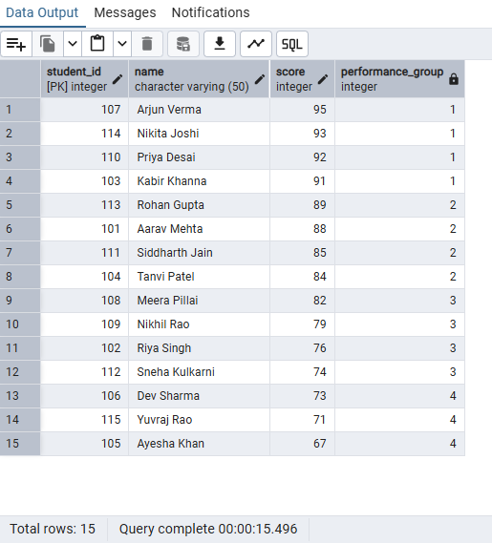

Explanation:
Divides class into 4 equal groups:
- Group 1 = top performers
- Group 4 = lowest performers

QUESTION 6 – For each course, assign row number based on attendance (highest first).

SQL Query:

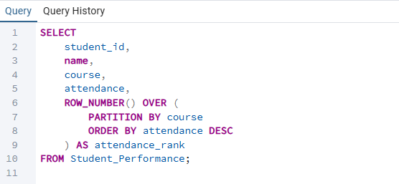

Output:

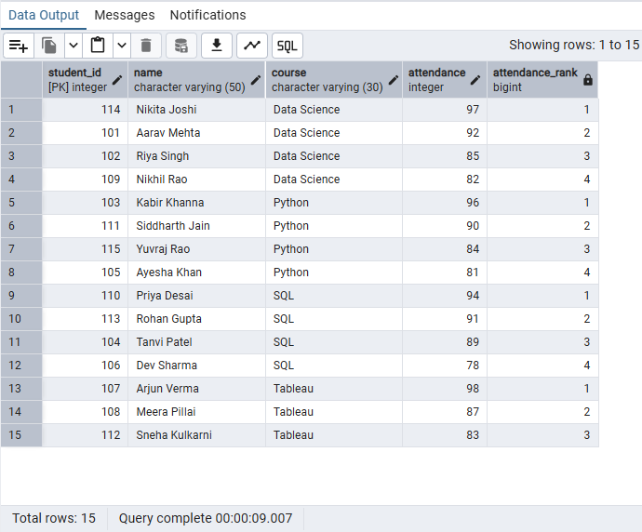

Explanation:
PARTITION BY course → ranking resets for each course.

QUESTION 7 – Number of days each student has been enrolled (Assume today = '2025-01-01').

SQL Query:
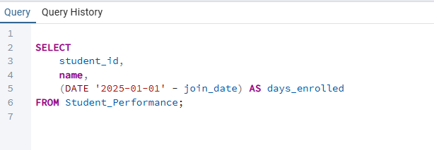
Output:
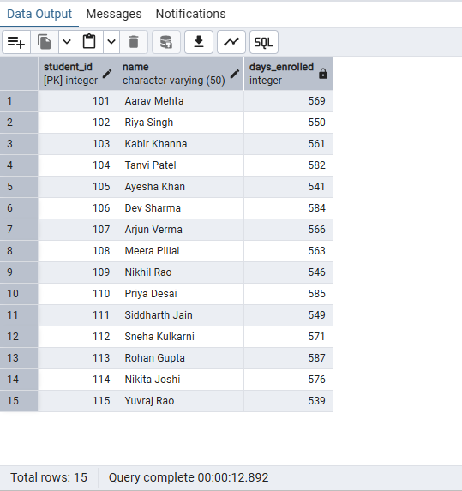

Explanation:
DATEDIFF() subtracts join_date from the given date.

QUESTION 8 – Format join_date as “Month Year” (e.g., “June 2023”).

SQL Query:

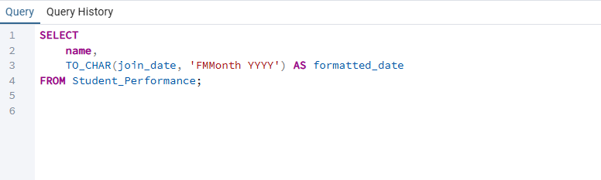

Output:

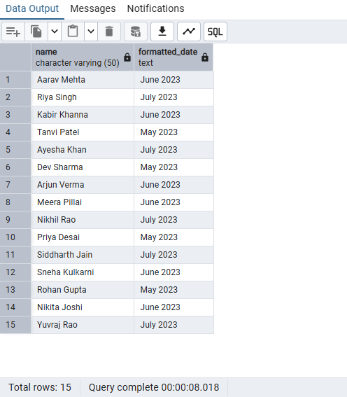

QUESTION 9 – Replace city ‘Mumbai’ with ‘MUM’.

SQL Query:

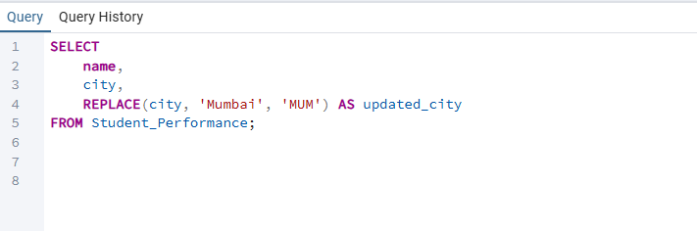

Output:

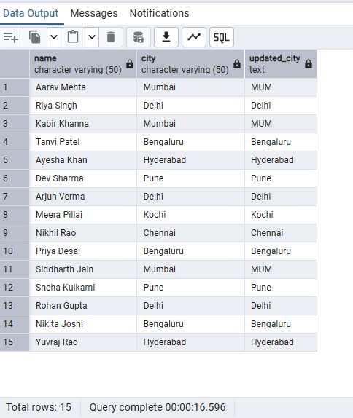

QUESTION 10 – For each course, find the highest score using FIRST_VALUE().

SQL Query:

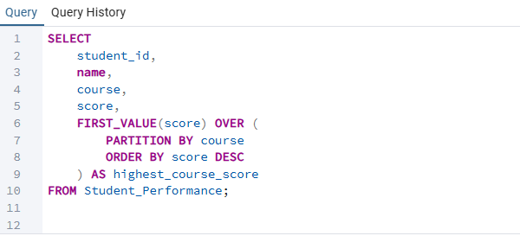

Output:

